

Vivek Mishra
CECS 561 - Hardware/Software Codesign Spring 2021

Advance System Report (Audio Recorder and Playback on Micro SD)

Introduction

I'll be using the Zybo Zynq-7000 SoC Development board for my embedded device in this project. In my basic project I will be loading an audio of five seconds on a micro sd card using Zybo-Z7 board and play it using external device like speaker or a headphone. For this project I have used some external hardware device like headphones or speaker. I have also used aux cable to connect the Zybo-Z7 board with the speaker. One more device was needed which is used to play a music or an audio file like a mobile phone or a laptop in order to record it on an SD card. Using the line-in or J5 port I recorded the audio in a 32 GB micro SD memory card in the Zybo-Z7 board. I'd also use the board's dip switches to monitor which track is played. Different parts of the boards, such as DDR memories, MIC in, HPH Out, and Line out, will be included in this project. On the Programmable Logic (PL) side of the board, I have used a new IP called Audio Codec IP for this. As the foundation for this project, I used the Digilent Zybo DMA Audio sample available on the Digilent website.

Operation

At first, I have used the proper version of the Vivado. The demo project was built on Vivado 2016, but I was using Vivado 2018. Although I was trying to make it work on it but due to the issues of the IP it was not working. In order to make it work I have upgraded the IPs and then run the generate bitstream to get fresh bitstream output. After doing this I have fix a code issue in the constraint file. The two port “iic_scl_io” and “iic_sda_io” were not appropriate as they were obsolete for the new version. In order to fix this, these ports were changed to “IIC_scl_io” and “IIC_sda_io”, i.e. iic was just changed to upper case. The design is then synthesized and the bitstream is produced. After that is completed, you can export the hardware and start the SDK. After the SDK is launched, we imported the SDK from the demo project. I have created a board support package with the required dependencies. When there are no further bugs, mount the board and verify the demo to ensure it is running correctly. In the application file I edited tow file that is demo.h and demo.c. Here I have included the below statement in demo.h.
#define DDR_BASE_ADDR XPAR_PS7_DDR_0_S_AXI_BASEADDR.
In demo.c file I included some logic to read and write on micro-SD card. For this I have used library xilffs. You can find the code on my GitHub.

Theory

The Audio Codec on the Zybo board is the key new hardware component I'm using (that we haven't used in class). The microSD slot on the Zybo board is included in the this version of the project. On the board's Processing System, the microSD slot is allowed by default (PS). I'm using the IP supported by the tutorial for the Audio Codec (see Figure below). The AXI S2MM, AXI MM2S, and AXI L signals are three of the most important signals on this block. The first two are responsible for data streaming to and from the codec and main DDR memory. The AXI L signals are AXI Interconnect "handshake" signals.
I have used C standard library to dynamically allocate memory for the audio recording and playback.

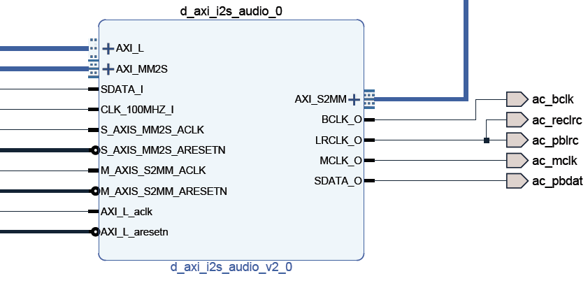

Hardware Source Code

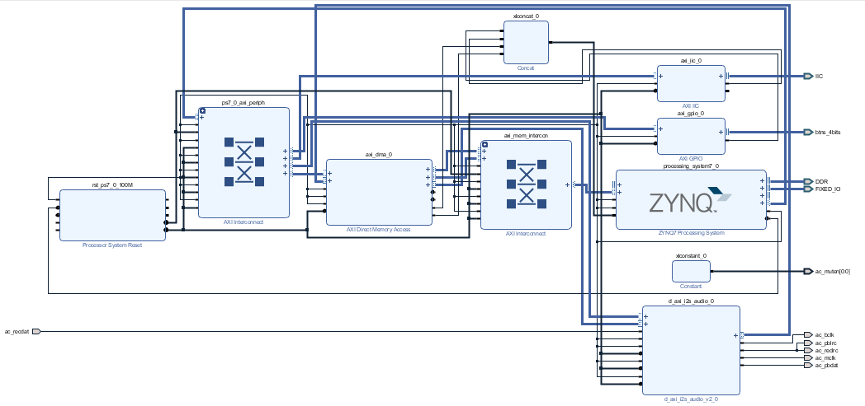

This is the current block diagram of the advanced project. You can see in I have added a Gpio switch too, which is functional and in this project it will record an audio and save it in the micro SD card with the name equal to the value of switches.

Software Source code

This project is similar to the basic demo project, except the functionalities have been changed. As previously said, several modifications have been made to the demo.h and demo.c files. (Note: Link to this file is in this GitHub link).

Conclusion

Working on this project was fun and it has lots of new learning as I have used a new functionality of the Zybo-Z7 board, however working on it was challenging as the old project was not functional with the new version of Vivado 2018. The demo project was built on Vivado 2016 due to which I have to go through some code fix and upgradation of IPs. Also, I hit an issue of “Recording never stops”, which make me think and after lots of research over internet I came to know I have to fix a hardware issue on the board rather than in the code. Documentation on Digilent website for the demo project was not enough. I have to go through many forums and after I even posted question on its forum to clarify my doubt. Finally, I was able to fix those issue with the help of my friends and the support forum the Digilent forum. For future work I will be uploading multiple audios on an SD card an play it.

